Table of Contents

MACHINE LEARNING CONCEPTS 2

MACHINE LEARNING PATHWAYS 2

TYPES OF MACHINE LEARNING 2

SUPERVISED MACHINE LEARNING 3

UNSUPERVISED MACHINE LEARNING 3

# MACHINE LEARNING CONCEPTS

## MACHINE LEARNING PATHWAYS

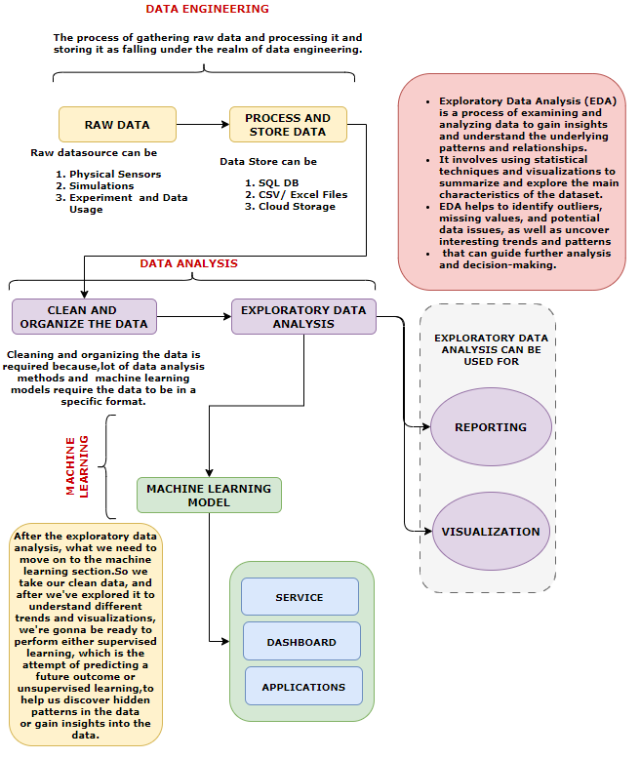

## TYPES OF MACHINE LEARNING

### SUPERVISED MACHINE LEARNING

### UNSUPERVISED MACHINE LEARNING